College of the Environment
Diversity Committee Meeting Minutes
Tuesday, March 17, 2020, 12:00 - 1:00 p.m.
Offered via Zoom: https://washington.zoom.us/j/202128588
(Facilitated by K.M-M. and E. Becceril Salas)

Invited members: K. Morrill-McClure (Co-Chair, WSG); E. Becceril Salas (Co-Chair, SEFS); S. Murray (Secretary; Nature and Health); T. Ross (Dean’s Office); I. Carrera Zamanillo (Dean’s Office); L. Exell (Advancement); W. Gibble (Botanic Gardens); T. Billo (Program on the Environment); K. Bumbaco (JISAO); J. Kobayashi (Marine Biology); A. Hanein (PMEL); B. Harvey (SEFS); S. Breslow (EarthLab); Sandy Wyllie-Echeverria (Friday Harbor); S. Saberi (SEFS); E. Myers (ESS); A. Boyar (OCN); B. Harding (SMEA); M. Sullivan (WSG)

Minutes
- Introductions and Welcome
  - Name, Unit, Pronouns
  - 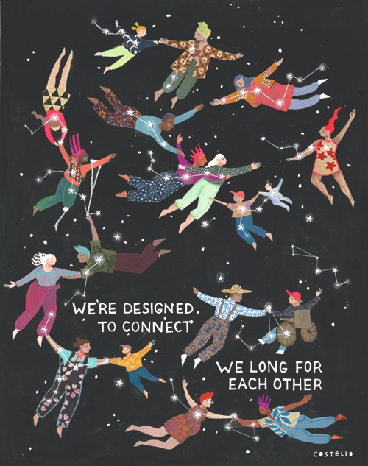
    - Artist, Molly Costello: http://www.mollycostello.com/largerpersonalwork

- Updates from CoENV Office of Diversity, (Terryl, Isabel) 7 min
  - Planned events may be postponed but they are looking at virtual conferences.
  - Videotaping presenters may be another option.
  - 201 class may be held online.
  - Earth Day: Intersectionality Project (possibly done virtually)
    - Ongoing efforts that can be done virtually:
      - https://green.uw.edu/earth-day-2020/pledge/full
      - https://green.uw.edu/earth-day-2020/intersectionality
  - More information about event format changes will follow.
  - Diversity Action Plan - Dean Graumlich has tasked the DEI office to lead the effort to create a diversity action plan for the college. To this end, we are in the process of creating a task force. If you are interested in serving on this task force, please fill out the following link: https://catalyst.uw.edu/webq/survey/tjross/380602. We will have our first meeting in the spring quarter.
- Unit updates, 5 min (new form!)
  - Botanic Gardens: DEI committee meeting monthly after a hiatus. We have a finalized DEI statement. We are currently working on assembling training materials from staff since we have not had money available at our unit for training. We are also working on resources for best practices for hiring managers. If other units are interested in teaming together on training and applying to CoEnv for funding, please email Wendy Gibble (wjgibble@uw.edu)
  - ESS: DEI priorities remain (1) Recruitment and retention, (2) Field-based teaching and research, (3) training and cultural change. We focus on structural change, transparency, and amplifying voices of affected communities, underrepresented groups.
    - Hiring training: our first push was on faculty hiring (ongoing), grad recruiting (winter 2020, and prep for AGU Bridge Program application fall 2020), and now started to implement this with staff hiring
    - Fieldwork: Held training with Disability Resources for Students. Made quick-start guide to requirements for all optional and mandatory course field trips highlighting equity issues, barriers, best practices. Spring 2020 workshop to improve field trips, syllabi and field trip guides for specific courses.
    - Culture change: Revamping process for >$250k in annual scholarships and awards (students, staff, faculty). Developing a rubric for scholarships and awards with an equity lens. Trying to implement a disclosure statement about professional misconduct, as people are required to sign for award applications of professional societies like AGU and GSA. Looking for examples on rubrics and disclosure statements!
    - GO-MAP process: We replied to the request from Anthony Salazar saying we wanted to apply with the College as we and other units have traditionally done. We did not realize that other units applied independently - three units that went independent were successful but the College was not. We later applied independently to UW for a Native American student but don’t know if we will get it. We’d like to know ahead of time if other units plan to apply for GO-MAP independently next year, in which case we will go independently, too!
  - FHL: DEI committee formed: First meeting will be March 20, 2020
  - JISAO: Had a microaggressions workshop scheduled for March 17. Currently postponed but looking into ways with our facilitator if this workshop could be possibly be done virtually.
  - Botanic Gardens: DEI committee meeting monthly after a hiatus. We have a finalized DEI statement. We are currently working on assembling training materials from staff since we have not had money available at our unit for training. We are also working on resources for best practices for hiring managers. If other units are interested in teaming together on training and applying to CoEnv for funding, please email Wendy Gibble (wjgibble@uw.edu)
  - Nature and Health:
    - Nature Interaction and Human Well-being: A Hypothesized Model of Feeling a Sense of Presence in Nature, Carly Gray, Ph.D. Student. RSVP: https://forms.gle/G3yyc21sdNDWbH1ZA
    - Possibly a Zoom Webinar: Health and Nature During Covid-19 (next week, more information soon!)
  - SEFS:
    - We had to cancel the final meeting of winter quarter but have just scheduled our spring quarter meetings.
    - We will be taking the outcome of our first SEFS DEI Open Meeting, held last quarter, along with our ongoing discussions as a committee, to focus our work in the coming quarter on the development of a new SEFS DEI Plan.
    - A major priority for work on that plan will be faculty hiring, as we have several upcoming faculty searches.
  - WSG: They are hosting virtual coffee breaks (30min.)
- Revisiting goals made from years past (Elena): A PowerPoint presentation listed themes and goals from years past: https://drive.google.com/drive/folders/0AACjCbrteaBIUk9PVA
- Conversation on goals outlined: will be a time for discussion where we will address the following questions as a group and within each department. https://drive.google.com/open?id=1wpXHYb5rOG6UjQl-f5ndqoAmVIb4us8j
- Questions:
  - What are some accomplishments within your department that you are proud of?
    - Maile: 2011 the committee was 12 people and now almost every unit has formed a committee. It’s great to see this worked being empowered at the unit level and then convening in this group.
    - Emma: Would like to digest this further and reflect on what was suggested and what to move forward on
    - Kate (ESS): Priorities are best practices in hiring and retention for students, staff, and faculty. Access and equity. Continuing DEI training. They want to implement best practices for each group: undergraduate/graduate, staff, faculty. Looking for opportunities and access for these groups and have a reflective practice where each group is involved in these solutions. They are proud of their shared vision around their goals.
    - Karen (WSG): Almost finished with the ten-year DEI roadmap: Short and long term goals. One priority is hiring. They are proud that they get to spend 10% of their time on DEI as employees of WSG.
  - What are the priority action items in your department that you feel are the most important? This can be broken up between undergraduate, graduate, staff, and faculty.
    - Some action items mentioned are listed above.
  - How can the diversity committee assist in ensuring each unit’s action items are achieved?
    - A survey will be sent out to our group to look at what each unit’s goal is and how we should achieve unit goals.
    - Jessica (Botanic Gardens): It would be great to develop a networking opportunity.
    - Kate (ESS): Develop some guidance about what we handle more at the unit level (with CoENV DC maybe facilitating information exchange and collaboration) and what the CoENV should take the lead on.
- Adjourn

