USDA Forest Service

Pacific Southwest Region
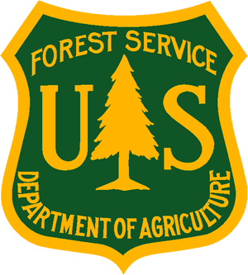
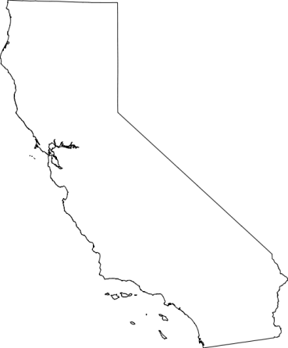
_______________________________
Outreach Notice
Klamath National Forest
Supervisor’s Office
___________________________________

Fire Ecologist
GS-0401-09
NTE 1 YEAR DETAIL OPPORTUNITY

The Klamath National Forest is currently seeking a candidate for up to a one year detail (with possible extension) for a Fire Ecologist (GS-0401-09) position with a duty location on the Happy Camp-Oak Knoll Ranger District.

The successful applicant will have a choice of duty stations of either the Happy Camp Ranger District Office or at Klamath River Station (aka Oak Knoll Station).

The purpose of this Outreach Notice is to inform prospective applicants of this upcoming opportunity. To express interest in this position and receive notification of the job announcement when it is issued, please complete the attached voluntary Outreach Interest Form and return to Chris Hays @ chays@fs.fed.us by close of business on 10/6/2016

DUTIES ASSOCIATED WITH THIS POSITION:

The successful applicant will be an integral part of planning and implementing special fuels projects on the Happy Camp-Oak Knoll Ranger District. Duties include participation as Lead Fire Ecologist on District Interdisciplinary Teams, working as Forest Service Fire Ecologist with non-Federal collaborative groups, advising and assisting in fuels treatment implementation, and assisting with the fuels contracting process.

Travel, per diem, and base salary will be paid by the Klamath National Forest. For more information on the position, contact Chris Hays at 530-841-4441 or chays@fs.fed.us.

ABOUT THE FOREST:

The Klamath National Forest covers an area of 1,700,000 acres located in Siskiyou County in northern California and Jackson County in southern Oregon. The Forest is divided into two sections separated by the Shasta Valley and the Interstate 5 highway corridor. In the mountains to the west, the terrain is steep and rugged while the east side has the relatively gentler, rolling terrain of volcanic origin. With elevations ranging from 450 to 8,900 feet above sea level, the Forest is one of America’s most biologically diverse regions, situated in a transition region between the hotter and drier areas of the south and the colder and wetter locale of the north.

This central position of the Klamath in relation to the Cascades, Sierra Nevada, Coast Range and the Great Basin has fostered complex climatic patterns and led to an unparalleled diversity of plant life found nowhere else in California. More species of conifers live near or in the Klamath’s Marble Mountain and Russian Wilderness Areas than anywhere else on earth. An astounding 17 conifer species co-exist within one square mile! The Forest is also home to one plant that lives nowhere else on earth, the Siskiyou Mariposa Lily.

The program of work for the Forest is centered on the restoration of fire adapted ecosystems. We have an active and strongly integrated vegetation management and fuels program that works to protect communities, infrastructure and critical wildlife and fisheries habitat. We work with local communities, Fire Safe Councils, and interested groups and individuals in developing projects using Healthy Forest Restoration Act authorities. In 2010, the Forest was honored to be recognized as having treated the greatest amount of hazardous fuels reduction acres in the Pacific Southwest Region.

The appropriate management of naturally occurring wildfire across the Forest is also an important program component. The Klamath is known as a leader in using wildfire to benefit landscape conditions as well as having a highly skilled and experienced fire suppression workforce.

The Forest includes all or part of five wilderness areas: Marble Mountain, Russian, Trinity Alps, Red Buttes and Siskiyou. Trailheads are numerous and hikes range from easy to arduous. There are 200 miles of river system for rafting and 152 miles of wild and scenic rivers in the Forest. The Forest has 28 campgrounds, and world-class hiking, fishing and wildlife viewing. With the Klamath, Salmon, and Scott Rivers meandering from one end of the Forest to the other, recreationists have found a playground that offers virtually everything (except crowds) to the outdoor enthusiast.

The management of area streams and rivers, and range, botanical, heritage, cultural and mineral resources rounds out the active and interesting programs included on the Klamath.

More information on the Klamath National Forest is on our website: http://fs.usda.gov/klamath/ .

ABOUT THE COMMUNITY:

HAPPY CAMP, CA

The Happy Camp/Oak Knoll Ranger District main office is located in the Town of Happy Camp, California. Happy Camp is a small, rural community located on the Klamath River in Northwestern California. Happy Camp has an active arts program, a Chamber of Commerce, medical and dental clinic and small commercial district with automotive repair, restaurants, feed store, groceries, gift and antique shops. There are motels, RV parks, outfitters and guides, community park and campgrounds. The Karuk Tribe headquarters and tribal offices are located in Happy Camp. There are salmon and steelhead fishing opportunities along the Klamath and Scott Rivers, and rainbow trout in our high elevation lakes. Other activities include hunting, camping, hiking, backpacking, rafting, rock-hounding, local festivities and the annual “Big Foot” day held on Labor Day weekend. The community of Happy Camp has a thriving local art community, as well.

Forest Service employees on the workforce reduction placement system list will receive priority consideration and CTAP/ICTAP candidates will receive the appropriate consideration.

The U.S. Department of Agriculture (USDA) prohibits discrimination on all its programs and activities on the basis of race, color, national origin, gender, religion, age, disability, political beliefs, sexual orientation, and marital or family status. (Not all prohibited bases apply to all programs.) Persons with disabilities who require alternative means for communication of program information (Braille, large print, audiotape, etc.) should contact USDA's TARGET Center at (202) 720-2600 (voice and TDD). To file a complaint of discrimination, write USDA, Director, Office of Civil Rights, Room 326-W, Whitten Building, 14th and Independence Avenue, SW, Washington, DC 20250-9410 or call (202) 720-5964 (voice and TDD). USDA is an equal opportunity provider and employer.

OUTREACH INTEREST FORM
NTE 1 Year Detail Opportunity
Fire Ecologist, GS-0401-09
Happy Camp-Oak Knoll Ranger District

Please respond by 10/6/2016

If you are interested in this position and would like notification of the job announcement when it is issued, please complete this Outreach Interest Form and email to Chris Hays at chays@fs.fed.us. If you do not have email, complete the form and mail to: Klamath National Forest, Attn: Chris Hays, 1711 S. Main Street, Yreka, CA 96097.

NAME:
E-MAIL ADDRESS:
MAILING ADDRESS
TELEPHONE NUMBER
AGENCY EMPLOYED WITH: |  |  | ☐ | USFS | ☐ | BLM |  | ☐ |  | OTHER
TYPE OF APPOINTMENT |  |  | ☐ | PERMANENT | ☐ | TEMPORARY | ☐ |  | TERM
 |  |  | ☐ | VRA | ☐ | PWD | ☐ |  | OTHER
CURRENT REGION/FOREST/DISTRICT
CURRENT SERIES/GRADE IF APPLICABLE
CURRENT POSITION TITLE
WHERE DID YOU HEAR ABOUT THIS VACANCY
IF NOT A CURRENT PERMANENT (CAREER OR CAREER CONDITIONAL) EMPLOYEE, ARE YOU ELIGIBLE TO BE HIRED UNDER ANY OF THE FOLLOWING SPECIAL AUTHORITIES
☐ | PERSON WITH DISABILITiES (SCHEDULE A APPOINTING AUTHORITY)
☐ | VETERANS RECRUITMENT APPOINTMENT (VRA)
☐ | 30% OR MORE DISABLED VETERAN
☐ | VETERANS EMPLOYMENT OPPORTUNItiES ACT OF 1998, AS AMENDED (VEOA)
☐ | FORMER PEACE CORPS VOLUNTEER
☐ | Pathways Program (Students, Recent Graduates, and PMF)
☐ | OTHER

Submission of this form is voluntary. Thanks for your interest!

