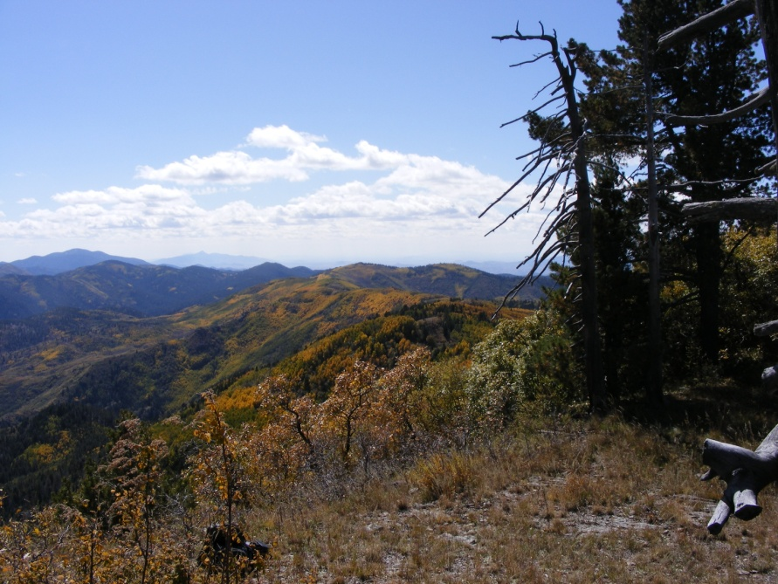
OUTREACH NOTICE

Gila National Forest
Supervisors Office
Silver City, New Mexico

Ecologist
GS-0408-11 (One Position)

Please respond by August 31, 2016

The Gila National Forest will soon be advertising a vacancy for an Ecologist, GS-0408-11. The position is a permanent full-time appointment, and will be located at the Supervisor’s Office in Silver City, New Mexico. The purpose of this Outreach Notice is to determine the potential applicant pool for this position and to establish the appropriate recruitment method and area of consideration for the advertisement (i.e. service-wide, government-wide). Responses received from this outreach notice will be used to make this determination.

Interested applicants or those desiring more information should contact Arthur Telles, Natural Resources and Planning Staff Officer, at atelles@fs.fed.us, and Gabe Holguin, Fire & Aviation Staff Officer, at gholguin@fs.fed.us or (575)388-8233.

VACANCY ANNOUNCEMENT

The vacancy announcement for this position will be posted on the U.S. Government's official website for employment opportunities at www.usajobs.gov.

INTRODUCTION

This position is located on the Gila National Forest where the incumbent serves in the near future as the Ecologist for land management planning. The Planning Team will be focusing on revising the Gila National Forest’s land and resource management plan (forest plan) over the next three to four years to incorporate changed conditions and best available science under the 2012 Planning Rule. The revised plan will be a collaboratively developed, science-based framework employing integrated resource management to guide project and activity-level decision-making. This position will also involve substantial innovative work with interdisciplinary specialists; collaborative groups; Forest Leadership Team; federal, state, and local officials; community leaders and organizations; and the general public. This is an outstanding opportunity for professional development, community involvement and program leadership.

Once the Forest Plan Revision process is complete, the position will become part of the very active Fire & Aviation Management organization at the Supervisor’s Office serving as the Fire Ecologist and providing information on wildland fire and fuels management methods to enhance, restore and protect ecosystems including fire adapted ecosystems. The incumbent will work closely with other resource specialists to integrate vegetation management project designs in the fuels program direction. Provides professional expertise in the development and implementation of multiple resource management objectives. Develops fuels treatment alternatives to support management decisions while adhering to applicable laws, regulations, policies, and guidelines. Participates in prescribed fire activities, wildland fire, and fuels management activities to ensure targets are achieved, management objectives are met and mitigation measures are adequate. Coordinates multi-disciplinary field studies related to fire and fuels management program issues to determine effectiveness of treatments. Coordinates and provides transfer of findings to the appropriate personnel. Provide technical advice on the WFDSS application, including short-term, near-term and long-term wildfire modeling.

Duties include:
- Serves as a member of an interdisciplinary team planning, developing, and implementing land management plans, compliance documents, and agreements.
- Compiling, evaluating, and analyzing data addressing ecological influences and dynamics, and natural processes of the forest (especially fire) as they relate to multiple uses (ecosystem services).
- Staying abreast of the legal aspects of forest planning and associated planning regulations as they pertain to ecological issues.
- Maintains awareness of technological developments in wildland fire science and related disciplines. Collects information through a variety of methods, including field surveys, computer modeling, and specific literature searches. Stays abreast of state-of-the-art computer modeling software and scientific methods to support fire use, air quality, and fuel treatment planning and applications.
- Helps coordinate collaboration and participation efforts with various stakeholders including Tribes, other Federal agencies, State and local governments, individuals, and public and private organizations or entities.
- Coordinating with the appropriate Forest and Regional Staff’s/Program Managers related to soil, water, air, vegetation, fire and fuels, range, and recreation.
- Giving professional presentations at various conferences and at other public forums.

Candidates that bring the following experience or background are especially suited to this position:
- Knowledge of principles of southwestern vegetation ecology (especially fire dynamics) including drivers, stressors, and trends, and evaluating their influences on ecosystem integrity.
- Knowledge of the principles and practices of land management planning.
- Ability to work effectively with other resource specialists in an interdisciplinary setting.
- Professional knowledge of natural resource management, fire ecology, fire behavior, and fire management theories, concepts, principles, and standards in a wildland fire environment.
- Knowledge of principles and practices of research and data collection.
- Effective communication and writing skills.
- Understanding of the interaction of natural processes and how these processes are affected by natural and human related disturbance.
- Drafting desired conditions and other plan components which are designed to move toward ecological sustainability.
- Knowledge of computer hardware and software programs, including Microsoft Office, State and Transition Modeling (VDDT), fuel/fire management modeling, ArcGIS, WFDSS and Internet applications.
- The ability to be flexible and think on your feet.

Gila National Forest

Every National Forest offers its own unique qualities. The Gila's beauty is in its diversity of rugged mountains, deep canyons, meadows, and semi-desert country. It is one of the more remote and least developed National Forests in the southwest. The Gila is the sixth largest national forest in the continental United States, covering 3.3 million acres of forest and range land.

The forest has a rich history of the Mogollon and Apache Indians, Spaniards, Mexicans, ranchers and prospectors. A few of the personalities from the past that have left their mark in the Gila include Apache Chiefs Mangas Coloradas and Geronimo, conservationist and author of the Sand County Almanac Aldo Leopold; Billy the Kid and other outlaws; and renowned lion hunter Ben Lilly.

Another unique beauty of the Gila National Forest is its wilderness. The Gila, Aldo Leopold, and Blue Range Wilderness areas offer unparalleled hiking and horseback riding. The 558,065-acre Gila Wilderness, created in June 1924 at the urging of the conservation pioneer Aldo Leopold, was the world's first designated wilderness.

Community: Silver City (or related area) www.townofsilvercity.org and the surrounding communities of Bayard, Santa Clara, Tyrone and Hurley are located in southwest New Mexico. Main access to Silver City is via Highway 180 north from Interstate 10 at Deming, NM. The elevation is 5,900 feet above sea level. The population of Silver City is approximately 13,000 and Grant County is about 29,000. Silver City was recently selected as one of the healthiest places to live and retire. It placed in the top 1% of over 3,000 communities our size or larger. Downtown Silver City is undergoing a revitalization effort and features many locally-owned shops and lots of art galleries. The community has two libraries and churches of all denominations. There are two newspapers, motels, radio stations, city and county offices and local retail businesses. Area attractions include City of Rocks State Park, Historic Pinos Altos and Western New Mexico University Museum http://www.wnmu.edu/univ/museum.htm.

Climate: Silver City boasts four gentle seasons. The average annual temperature is 54 degrees. May is the driest month of the year while July is the wettest. The annual average precipitation is 15.69 inches.

Medical: Silver City has a Regional hospital http://www.grmc.org/, several medical clinics, ambulance service, an emergency care clinic, and physicians of all specialty areas, dentists and nursing homes.

Schools: Grant County has two public school districts. There are several private schools and alternative schools. Western New Mexico University www.wnmu.edu/ offers four-year programs and two year technical programs in areas such as education, nursing, basic arts and sciences and several graduate programs.

Employment: Major employers are Freeport-McMoRan Copper & Gold, Gila Regional Medical Center, Silver City Schools, Western New Mexico University, Walmart, Town of Silver City, Grant County, and the Gila National Forest.

Housing: Rentals range from $600-$1000 per month for an average three bedroom home/apartment. Prices of single family homes range from $85,000 and up.

Transportation: The nearest commercial airports are in El Paso, TX (3 hours), Tucson, AZ (3 hours) and Albuquerque, NM (4 hours). Grant County airport provides daily services. There is a shuttle service for transportation to Las Cruces and El Paso and a local transportation service to all the surrounding communities.

Additional Information: For additional location information visit the following web sites:
Gila National Forest Website | www.fs.fed.us/r3/gila
Grant County Chamber of Commerce | www.silvercity.org
Silver City Chamber of Commerce | www.townofsilvercity.org

OUTREACH RESPONSE FORM
Ecologist GS-0408-11 (One Position)

Please return by August 31, 2016

If you are interested in this position, please complete this form and email to Arthur Telles, at atelles@fs.fed.us If you have questions about the position call (Arthur Telles 575-388-8417 or Gabe Holguin 575-388-8233).

PERSONAL INFORMATION:

Name: |  | Date:

Address:

Email Address:

Phone:

Are you currently a Federal employee? | YES: |  | NO:

IF YES: Current Agency and location:

Current Title/series/grade/Level:

Type of Appointment: | Permanent |  | Term |  | Temporary

If you are not a current permanent employee (career or career conditional), are you eligible for appointment under any of the following special authorities?
Person with Disabilities
Veterans Recruitment Act
Former Peace Corps Volunteer
Disabled Veteran with 30% Compensable Disability
Pathways Program
Veterans Employment Opportunities Act of 1998
Other, please describe:

Briefly describe your qualifications/interest in this position (type answer into box, which will expand as needed):

Thank you for your interest in our vacancy!

USDA is an equal opportunity provider, employer, and lender

