HSC 10 Meeting Agenda

February 25, 2013

2:00pm-3:00pm at SEFS,

Anderson 107A

2:00-2:05 Approve January meeting minutes

2:05-2:10 Open OARS (KH)
- 2012-10-077 (Fisheries: Open wound, No Superv Comments)

2:10-2:20 January OARS to review (4)

2:20-2:35 U-wide H&S news (DZ)
- Stuart Cordts – 2012 OSHA 300A Accident Statistics
- EH&S Board meeting report – no report
2:35-2:45 Open floor (All)
- 2013 presentations: Ergonomics, Lab Survey Program, Violence in the Workplace Prevention, UW Marijuana policy (DZ scheduling, stay tuned)
- Other?

2:45- 3:00 Adjourn

Next Meeting: March 18: Same time and place, unless notified otherwise.

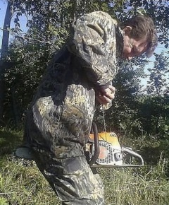
How to start a chain-saw: NOT!!!!

